Hand Sanitizer & Water
Station
- Shape hand as seen in the figure below:

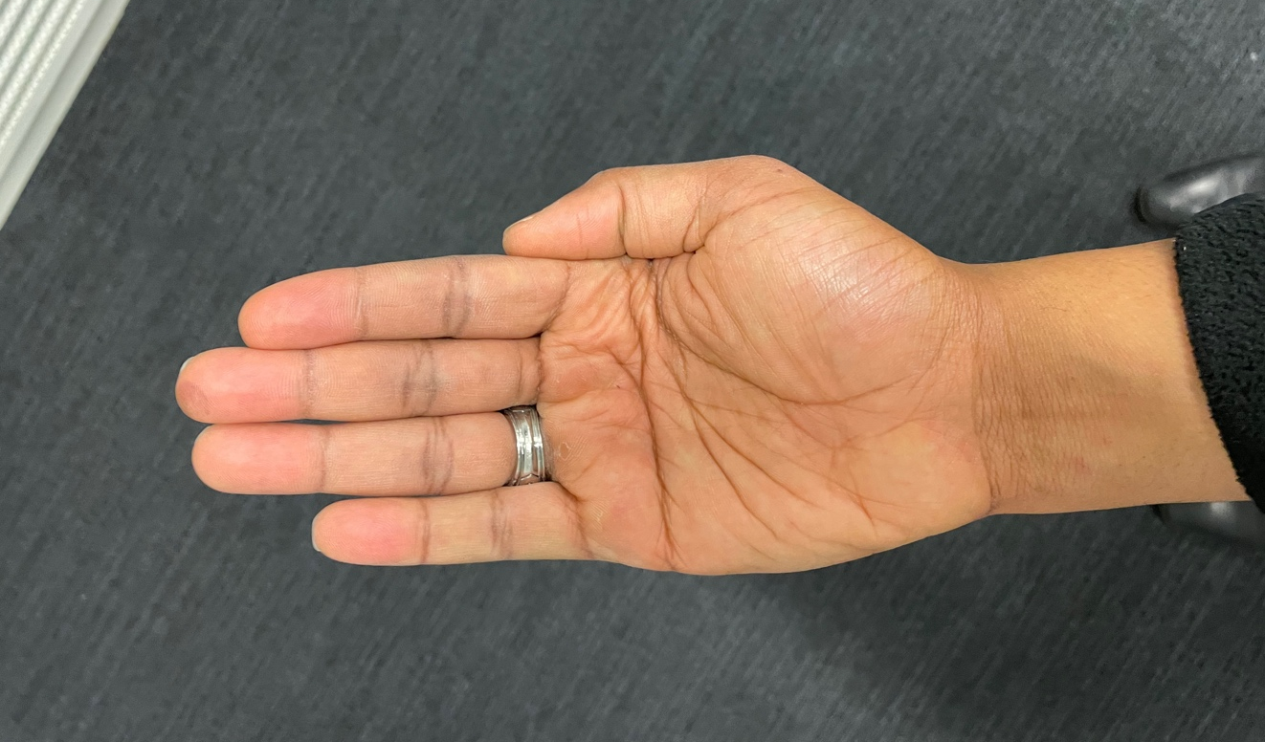

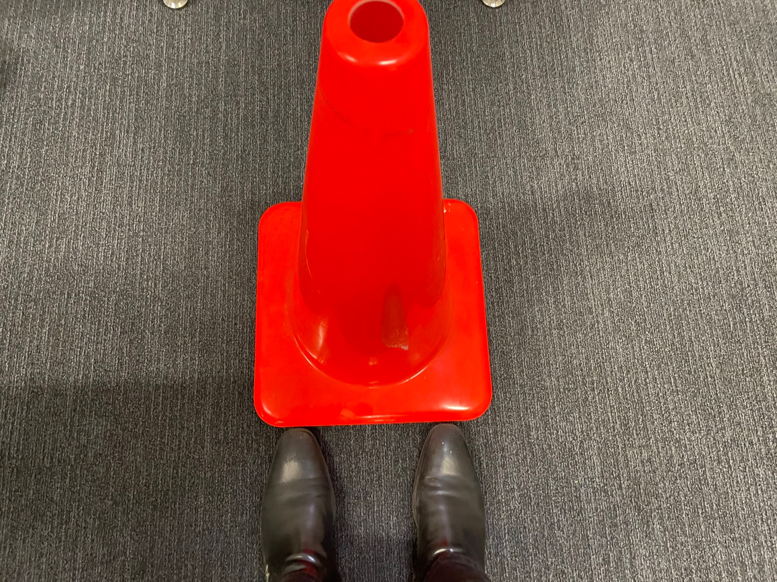
- Stand behind the cone labeled “Stand Here”:

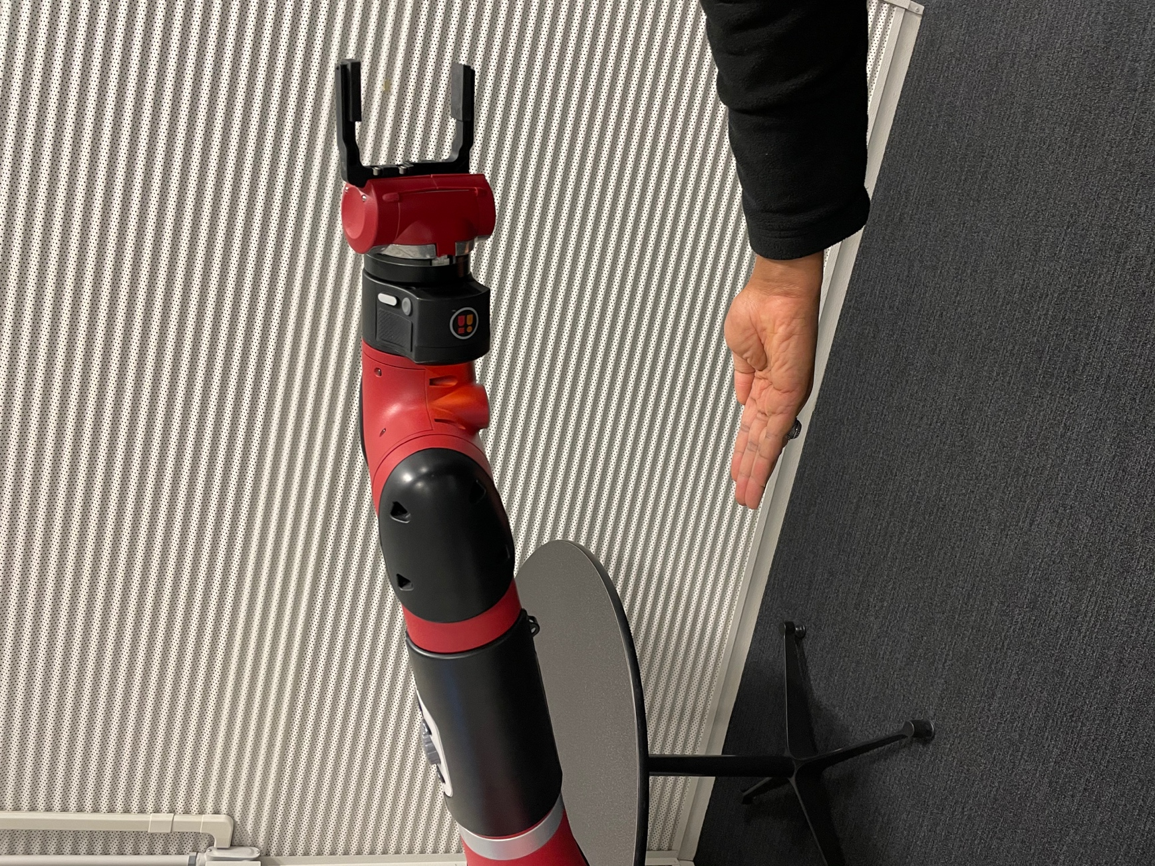
- Place palm 8-12 inches directly below the scanner:

- When robot approaches with water, firmly grab bottom of the bottle and lightly pull until it is released:
